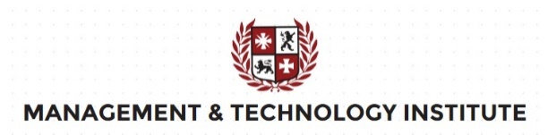
Application
Executive leadership MBA course

Name
First Name
Birth Date
Nationality
Country of residence
Email
Mobile Phone
Main education
Main motivation to participate in our executive leadership MBA?
Notes :
- This application is not binding and comes effective with conformation from the MIT.
- The MIT executive leadership MBA course is completely free. We will never ask you to pay anything.

- Please send to: admissions@leadership-mba.com
- This application completely filled in and duly signed
- A copy of : Passport, or ID Card, Or drivers license
- After submitting your application, you will within 7 days receive:
a) Confirmation e-mail
d) Study guide
c) Login Data to our self-study online platform
- MTI (Management & Technology Institute) reserves the right to refuse any application/inscription without the need of giving an explanation. Available study seats are limited.
DATE: NAME : SIGNATURE:

